**BloodMe**

**Abstract**

There is a steady increase in blood donation requests and seeking blood donors. Finding blood donor is a challenging issue in almost everywhere. There are some blood donor finder applications in the market. However, more reliable applications that meet the needs of users are prompted. BLOODME is android mobile application to help the potential users with urgent blood supply.

Blood is a vital element of human body. Finding a blood within a limited group of people in limited time is extremely difficult. BLOOME application provides a reliable platform to connect local blood donors with patients. BLOOME creates a communication channel through a app whenever a patient needs blood donation. The targeted users are people who needs blood and the people who wants to donate the blood in nearby city based on their location.

**Methods**

Different software tools and technologies including languages and framework are used to develop our blood-provider mobile application known as BLOOME application. These technologies comprise Java programming language and Google Firebase for database that are used. Android Studio is open source mobile app development platform that makes it possible to quickly and easily create data-based web applications.

The application is comprised of different functionalities such as ‘Signup’, ‘Login’, ‘Blood Request’, ‘Blood Donate’, and ‘Forget Password’.

‘Login’

Rupak Kadel implemented the Login part of the project. To get access to the app, user needs to sign into the app at first. The user needs to put his email address and his password that he registered during sign up phase to get entry into the app. After that, he can request the blood or donate it according to his/her need. From the login page, user can go to the sign-up page if he has not registered the account yet. If the information does not match the information we have in Firebase Database, the login will be denied.

‘Blood Request’

Roshan Dhamala

‘Blood Request’ is one of the major functionalities in BLOODME app. When a patient needs a blood, user will register with the patient’s information such as Name, Age, Blood group and Address. Once they provide with all the necessary information, they can request their desired blood. If there is matching blood group in the database, the app will show the information about the blood donors. Then, requester can directly contact to donors and get the desired blood.

‘Blood Donor’

Nikesh Prajapati

In this use case diagram, there will be a user to input information and database administrator to store the information. The above use case diagram allows the user to donate the blood but first the user need to include their personal information such as name, age, blood type and their address. To donate the blood user needs to create an account which goes into our database and only he/she can input their information. Later we match the information of the donor and requestor and match the blood type accordingly to donate the blood.

‘Sign up page’

Sujan Bhattarai

This blood me app allows to user to request and donate the blood if anyone needed. When we open the Blood me android application the main page shows on the app is sign in page after the sign page if the user does not have the account this page allows to user to create a user account. User will enter their information (names, email address, date birth, phone Number, Password and reenter the password). The information will save into the database for the future reference the user sign up page allows the user to sign up for the user account and user will have access information like find the hospital, doctor, location to donate the blood, send notification to another user who are able to donate Blood.

‘Forget Password’

Santosh Shrestha

We are group of five working on project which an android app which is basically used to request blood from the nearby users. We have implemented five use-case where my part is to work on ‘Forget Password’ layout. First, I create project called Project1 on git and I fork the project with base user which is another group member. Whenever user creates his profile on our system it is saved on the database. Whenever he tries go online, he has to login using his user id and password. If he forgets his password, he has option to set new password through ‘forget password’ button on login page. Forget password use-case is connected to login page and includes user email for validation and change password option.

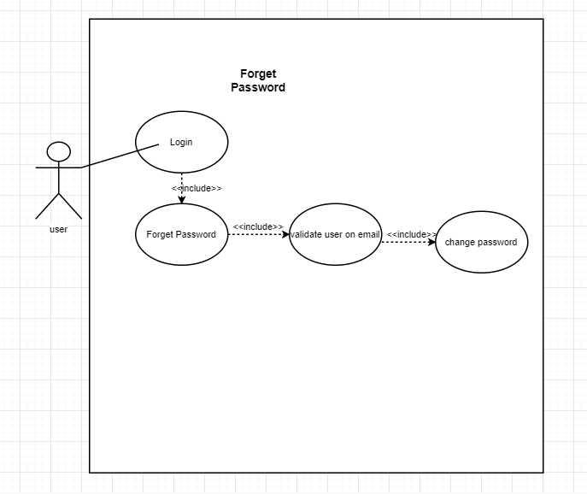

**Results**

The BLOOME application have different types of users including requester, donor, and administrator. Various features of the application are described, and their needs of use are analyzed. If a patient needs a blood, blood donors in vicinity can be contacted through using our app based on their location. Registered donors will get notification for the blood requests only if their blood group is compatible with the requested blood type and in the same city/region. Then matching blood donors can go to the hospital/clinic and donate.

**Conclusions**

The primary motto of BLOOME application is to create a platform to connect local blood donors with patients. It is a useful tool to find compatible blood donors who can receive blood request posts in their local area. The application will have a feature of ‘Special Notification’ that will be sent to donors who have the same blood group and from the same area as well as to requesters if matched.